Git Workflow - GitHub CLI Workflow

1️⃣ (First Time Only) – Login with GitHub CLI
# Source: AI Source: Provided by: [Data Path: Persons Table -> ID Column: 1, Name_En Column: Motasem Essam] -> From: [Chatgpt (GPT‑5 Mini)] on [2/19/2026]
Authenticate your machine with GitHub:
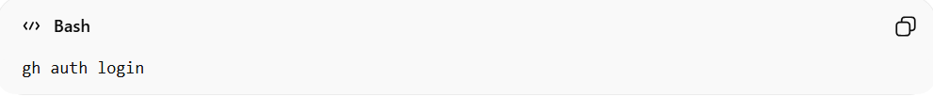
gh auth login
Follow the prompts:
- Choose GitHub.com
- Choose HTTPS or SSH
- Authorize in browser
Now your Git is connected to GitHub securely ✅

2️⃣ Add Changes
# Source: AI Source: Provided by: [Data Path: Persons Table -> ID Column: 1, Name_En Column: Motasem Essam] -> From: [Chatgpt (GPT‑5 Mini)] on [2/19/2026]
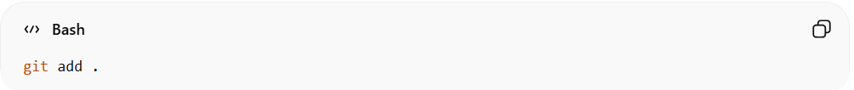
git add .
Or specific file:
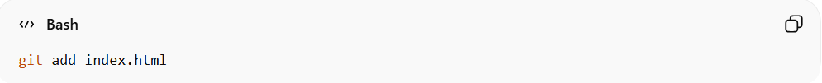
git add index.html

3️⃣ Commit Changes
# Source: AI Source: Provided by: [Data Path: Persons Table -> ID Column: 1, Name_En Column: Motasem Essam] -> From: [Chatgpt (GPT‑5 Mini)] on [2/19/2026]
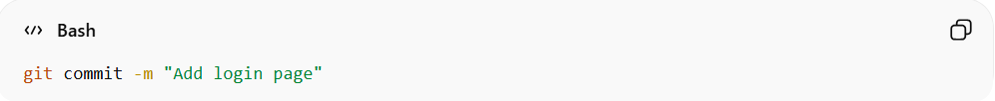
git commit -m "Add login page"

4️⃣ Push to GitHub
# Source: AI Source: Provided by: [Data Path: Persons Table -> ID Column: 1, Name_En Column: Motasem Essam] -> From: [Chatgpt (GPT‑5 Mini)] on [2/19/2026]
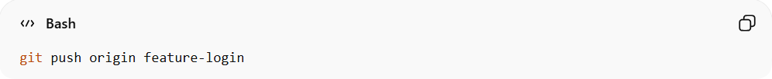
git push origin feature-login
If first time pushing the branch:
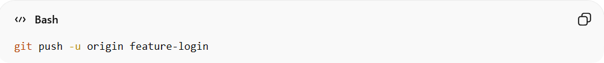
git push -u origin feature-login

5️⃣ Create a Pull Request Using GitHub CLI
# Source: AI Source: Provided by: [Data Path: Persons Table -> ID Column: 1, Name_En Column: Motasem Essam] -> From: [Chatgpt (GPT‑5 Mini)] on [2/19/2026]
After pushing your branch, you can create a PR directly from terminal:
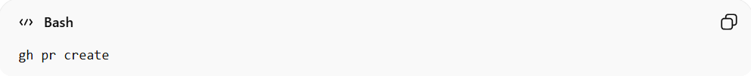
gh pr create
It will ask:
- Base branch (usually main)
- Title
- Description
Or do it directly:
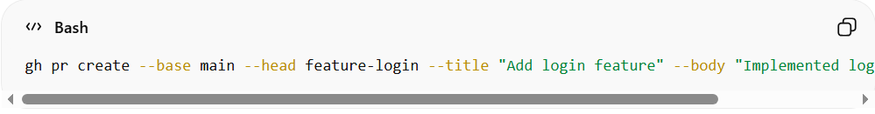
gh pr create --base main --head feature-login --title "Add login feature" --body "Implemented login functionality"
breakdown:
- gh → GitHub CLI
- pr create → Create a Pull Request
- --base main → Merge into main (target branch)
- --head feature-login → Merge from feature-login (source branch)
- --title → Pull Request title
- --body → Pull Request description

🔁 Full Workflow Example
# Source: AI Source: Provided by: [Data Path: Persons Table -> ID Column: 1, Name_En Column: Motasem Essam] -> From: [Chatgpt (GPT‑5 Mini)] on [2/19/2026]
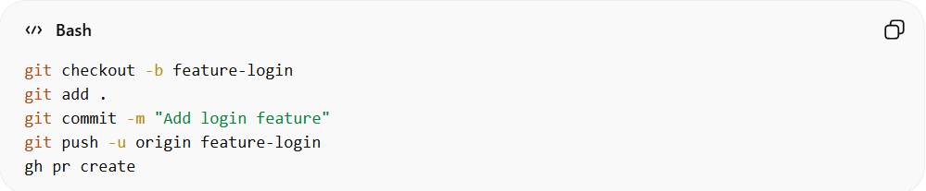
git checkout -b feature-login
git add .
git commit -m "Add login feature"
git push -u origin feature-login
gh pr create

🧠 What gh Actually Does
# Source: AI Source: Provided by: [Data Path: Persons Table -> ID Column: 1, Name_En Column: Motasem Essam] -> From: [Chatgpt (GPT‑5 Mini)] on [2/19/2026]
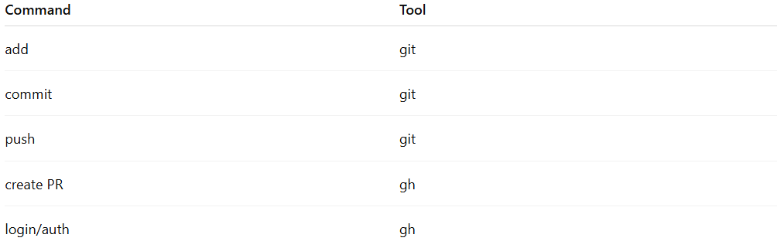
Command | Tool
add | git
commit | git
push | git
create PR | gh
login/auth | gh

So remember:
git = version control
gh = GitHub platform interaction

Example

1️⃣ (First Time Only) – Login with GitHub CLI
# Source: ScreenShots Source: Provided by: [Persons Table -> ID Column: 1, Name_En Column: Motasem Essam] -> Tool: [Lightshot Program] -> From [Site: https://github.com] on [2/17/2026]
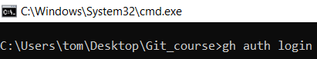
gh auth login
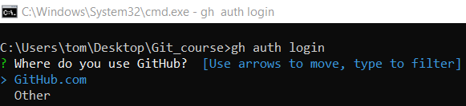
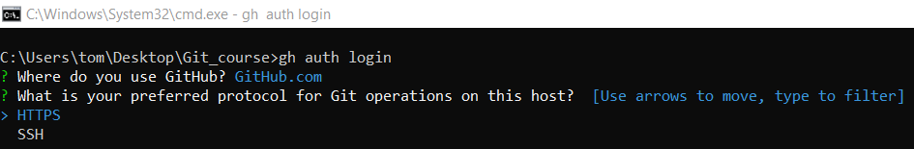
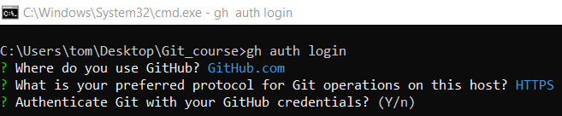
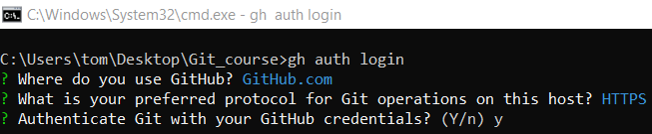
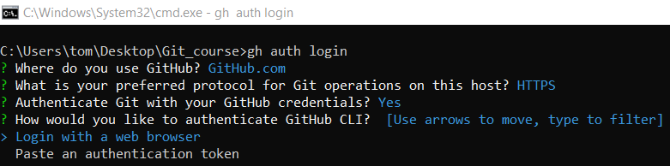
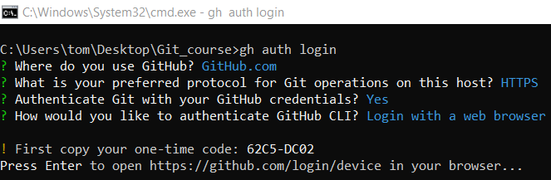
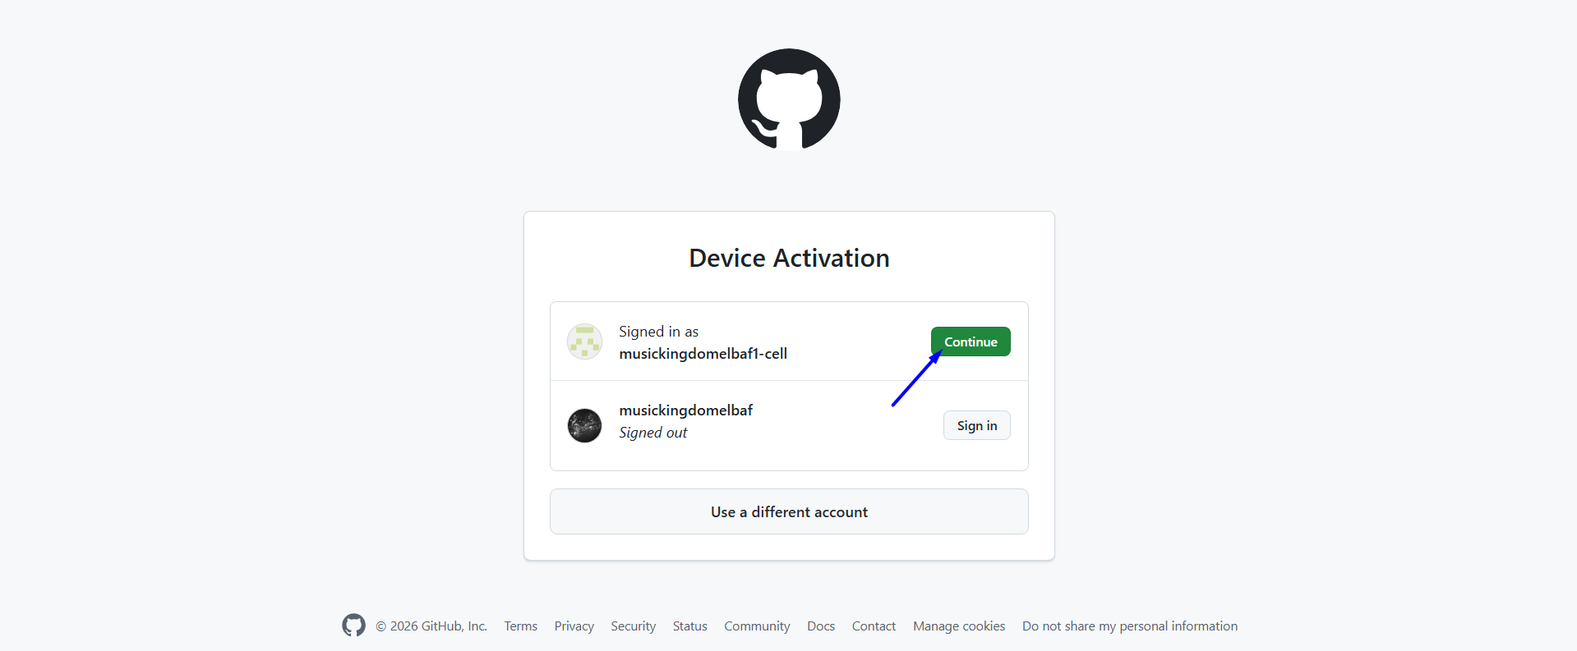
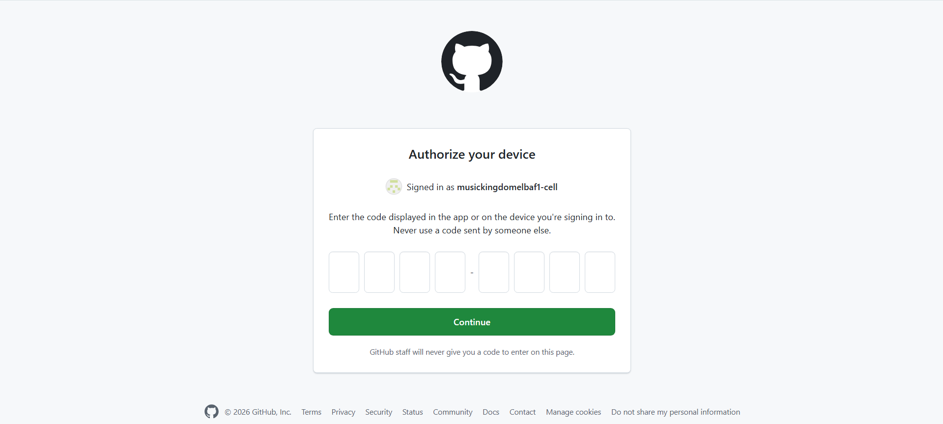
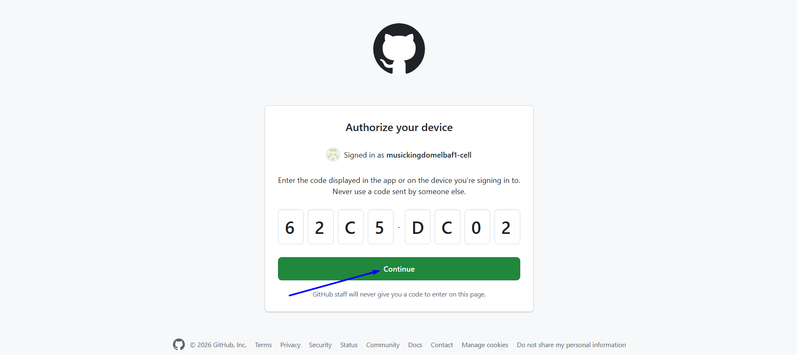
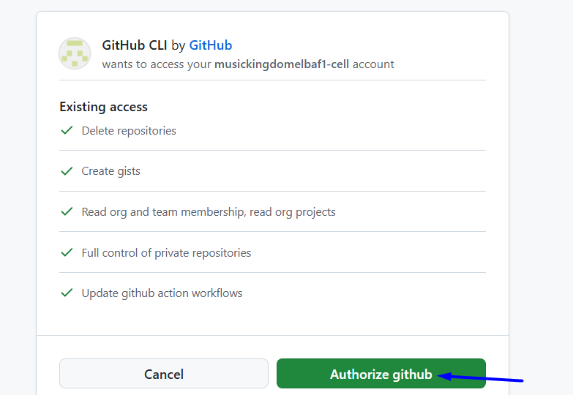
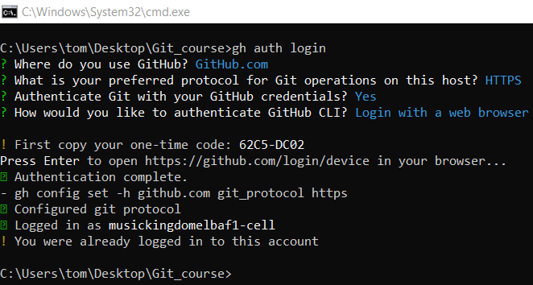

2️⃣ Add Changes
# Source: ScreenShots Source: Provided by: [Persons Table -> ID Column: 1, Name_En Column: Motasem Essam] -> Tool: [Lightshot Program] -> From [Site: https://github.com] on [2/17/2026]
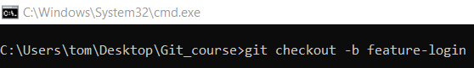
git checkout -b feature-login
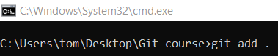
git add .

3️⃣ Commit Changes
# Source: ScreenShots Source: Provided by: [Persons Table -> ID Column: 1, Name_En Column: Motasem Essam] -> Tool: [Lightshot Program] -> From [Site: https://github.com] on [2/17/2026]
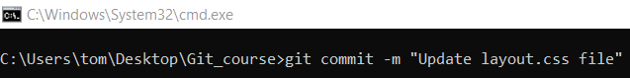
git commit -m "Update layout.css file"
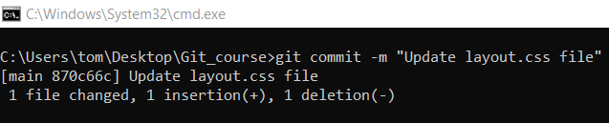

4️⃣ Push to GitHub
# Source: ScreenShots Source: Provided by: [Persons Table -> ID Column: 1, Name_En Column: Motasem Essam] -> Tool: [Lightshot Program] -> From [Site: https://github.com] on [2/17/2026]
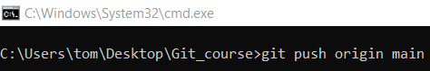
git push origin main
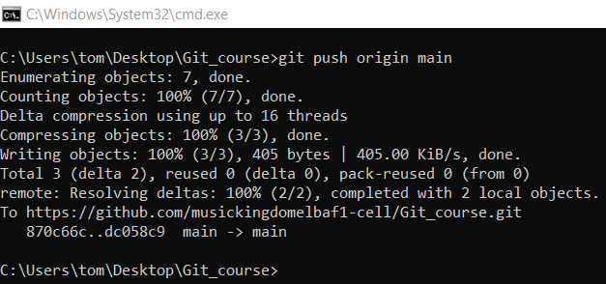

5️⃣ Create a Pull Request Using GitHub CLI
# Source: AI Source: Provided by: [Data Path: Persons Table -> ID Column: 1, Name_En Column: Motasem Essam] -> From: [Chatgpt (GPT‑5 Mini)] on [2/19/2026]
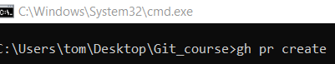
gh pr create
